Nemo
WEB SERVICE HOTELES CERTIFICATION

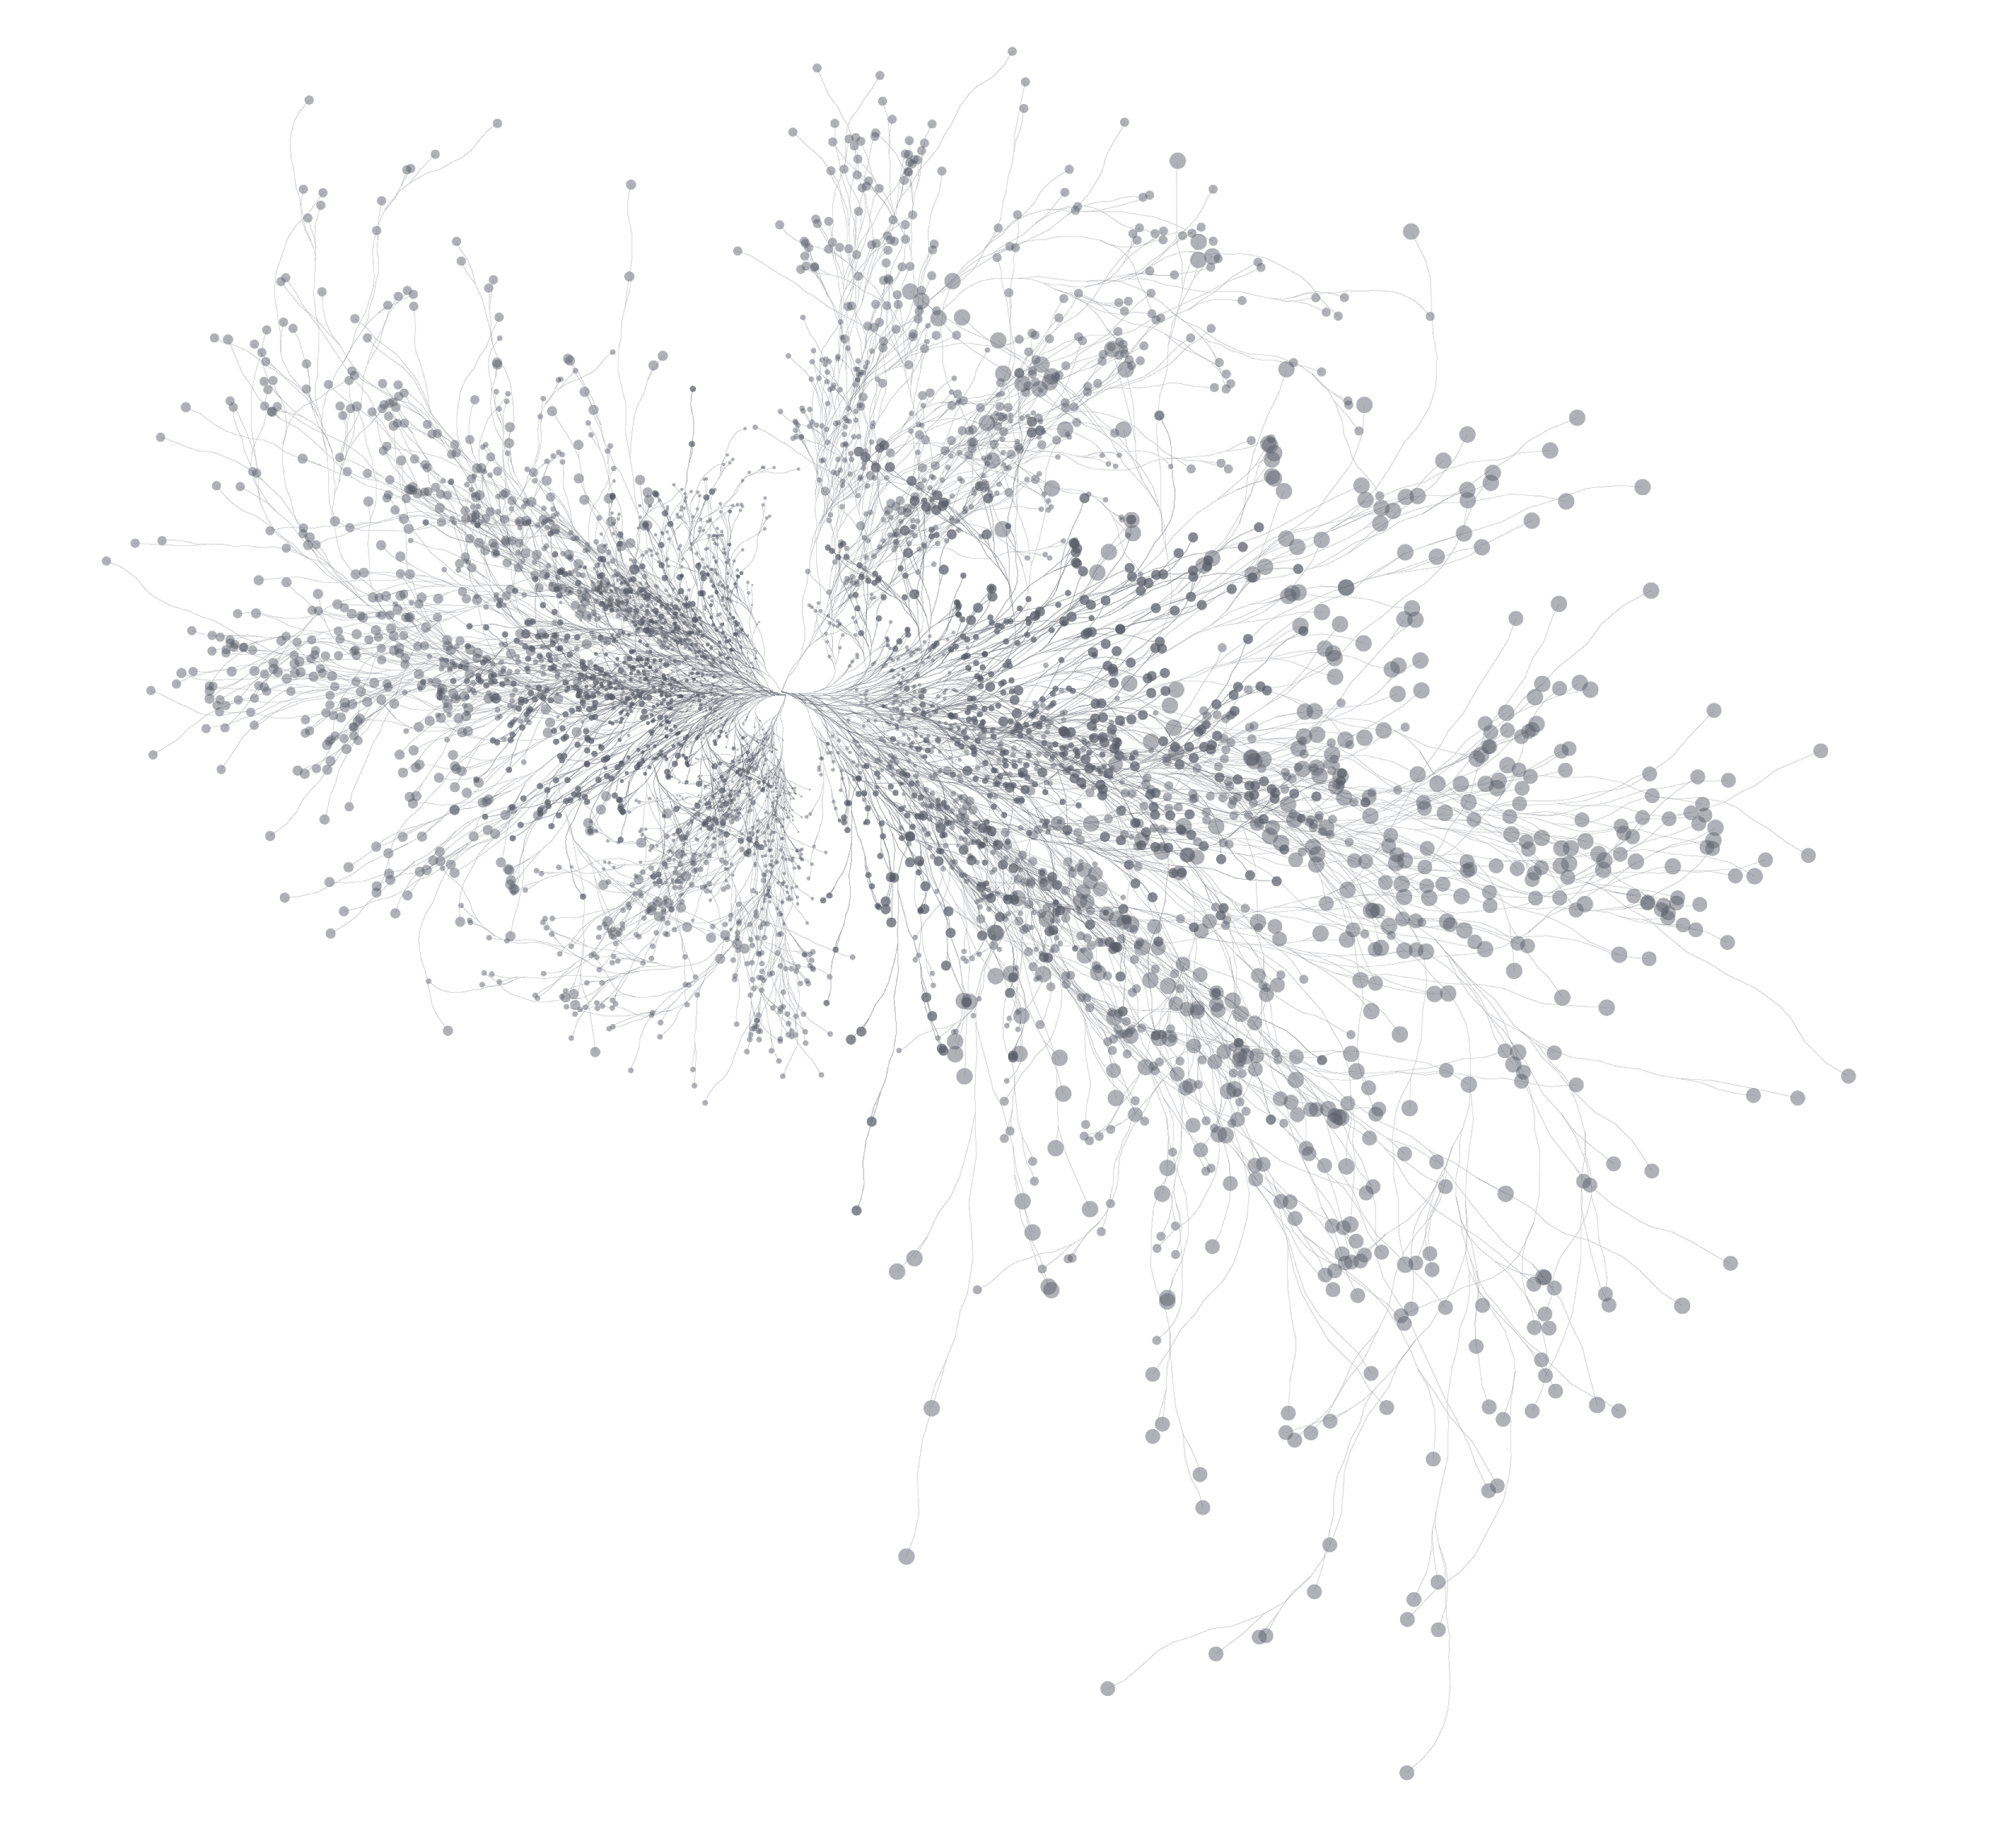

1.-) DEFINITION OF THE SCOPE OF CERTIFICATION
1.1.-) Objetive
The objetive of this document is to guarantee the quality of the hotel web services´ implementation related to the searches, information, book and cancelation, in order to maximize the experience of using the tool and the business.

1.2.-) Conditions assumed
The customer managed the integration according to the documentation entered in the Wiki http://wiki.psurfer.net/ considering the latest versions exposed at the time of integration.

As of October 2022, a list of enabled IPs is required to be able to operate, the IPs that are not informed as authorized will be blocked, preventing the operation

2.-) SCOPE OF CERTIFICATION
2.1.-) Services to be certified
Considering that NEMO hotels currently has the services detailed below under the following structure, mark in the box below, which are the ones that you would be interested in certifying; always bearing in mind that the preceding one has to be certified to request the later one.

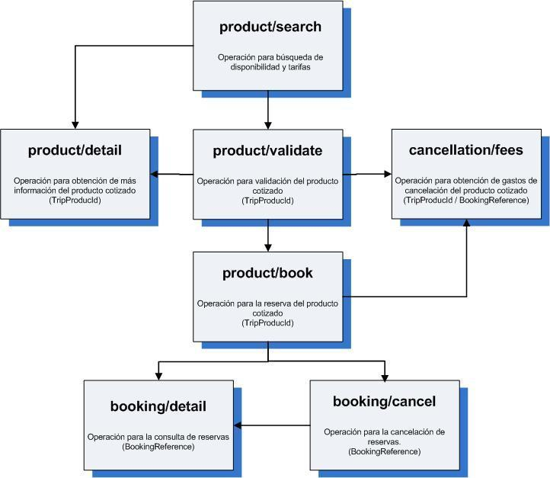

Services | Certification
/catalog/products/search | Yes / No
/catalog/product/detail | Yes / No
/catalog/product/valídate | Yes / No
/catalog/product/book | Yes / No
/booking/cancellation/fees | Yes / No
/booking/detail | Yes / No
/booking/cancel | Yes / No

3.-) DEVELOPEMENT CONSIDERATIONS
3.1.-) Developement
Detail how you have worked the following items

Asunto | Detalle
Cache of hotel static information
Hotel static information update
Search results cache for 30 minutes
Do you have automatic cancellation? In case your answer is YES, do you carry out the detail query (Booking query) immediately after the confirmation?
Add list of ips to enable to be able to operate.
4.-) IMPLEMENTATION´S USE
4.1.-) Display
Report in the following table where the implementation of the tool is displayed and where it will be displayed and what type of market it is targeting (B2B, B2C, other)

Version | URL | Target
Test / Prod
Test / Prod
Test / Prod
Test / Prod
4.2.-) Usage perspective
Mark in the following table what perspective of use the tool will have. If you consider that the combination of levels is different according to the criteria, select the highest. Please note that this measurement is not of your site in general but of hotels in particular.

Level | Number of simultaneous users | Number of monthly users | Number of monthly reservations
A | 0 – 10 | 0 – 5.000 | 0 – 50
B | 11 – 25 | 5.001 – 12.000 | 51 – 120
C | 26 – 50 | 12.001 – 45.000 | 121 – 450
D | More than 50 | More than 45.001 | 451 – or more

5.-) BOOKING FLOW
Graph the booking flow developed

6.-) BOOKING TEST
6.1.-) Display
Make the following reservations, including the screenshots of each step and the reservation code id
- 1 reservation with two rooms, one double and one single
- 1 reservation with one room, a double with two children (one with 5 years old and the other 2 years old)

7.-) CONTACTS
Please complete the following table with the people to be contacted with any questions

Empresa | Cargo | Nombre | e-mail
Nemo Group | Soporte | Mariano Bertello | support@pricenavigator.net

8.-) NEXT STEPS
8.1.-) Certification Result
The NEMO technical team will review the implementation according to the detail provided and will generate a response within 72 hours
If everything is in good conditions, the production key will be sent to the contacts indicated in this document
The use of these credentials excludes the possibility of applying them for other purposes such as working with a robot that performs availability searches to obtain rates and store them or any other task not specified in this document; reserving NEMO the right to disable the user. Any change you want to make must be notified and approved in advance
If any adjustment is required, it will be informed to the contacts detailed in this document so that it can be carried out.

9.-) CERTIFICATION APPLICANT
Certification requested by:

Name:___________________________________
E-mail: ___________________________________
Developer Company: _________________________
Company for which the development was made: ______________________

